**Lab Assignment 01**

CSE370, Section-03

Summer-2024

S. M. Ababil Islam

ID. 22301182

**Answer of Task-01:**

*Step-01:*

create database cse370assignment01;

show databases;

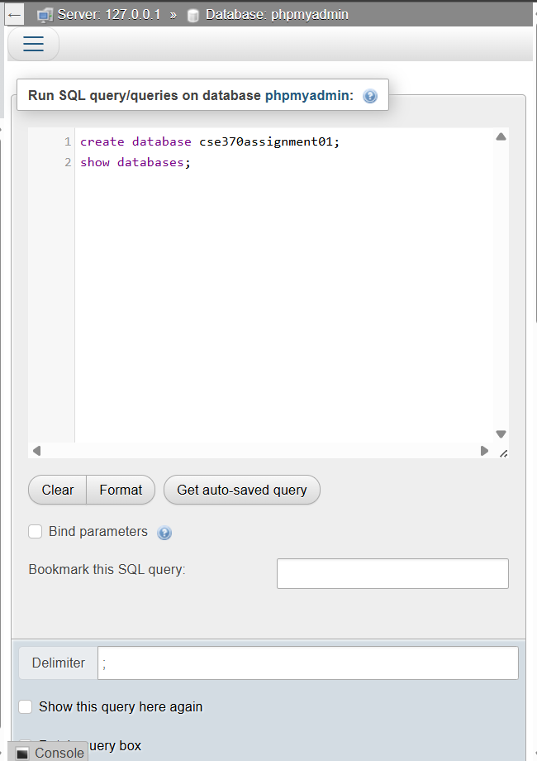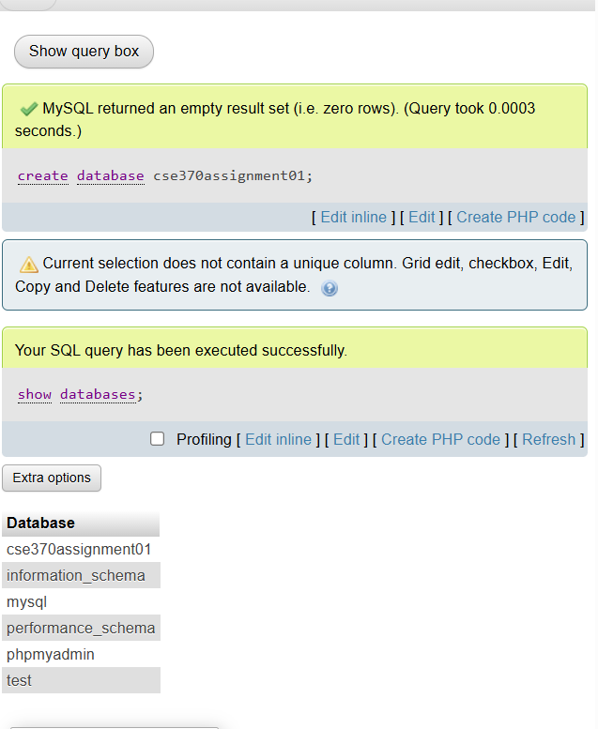

*Step-02:*

use cse370assignment01;

create table Developers

(

member_id char(2),

name varchar(30),

email varchar(50),

influence_count int,

joining_date date,

multiplier int

);

describe Developers;

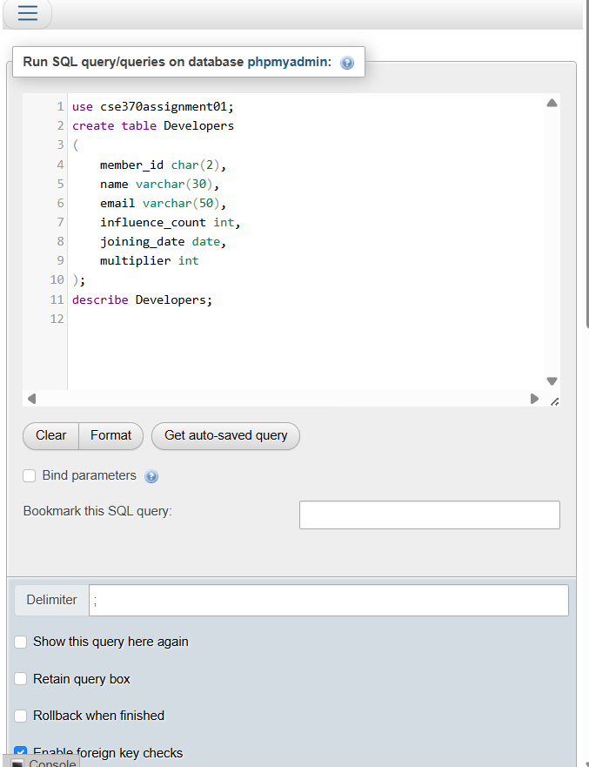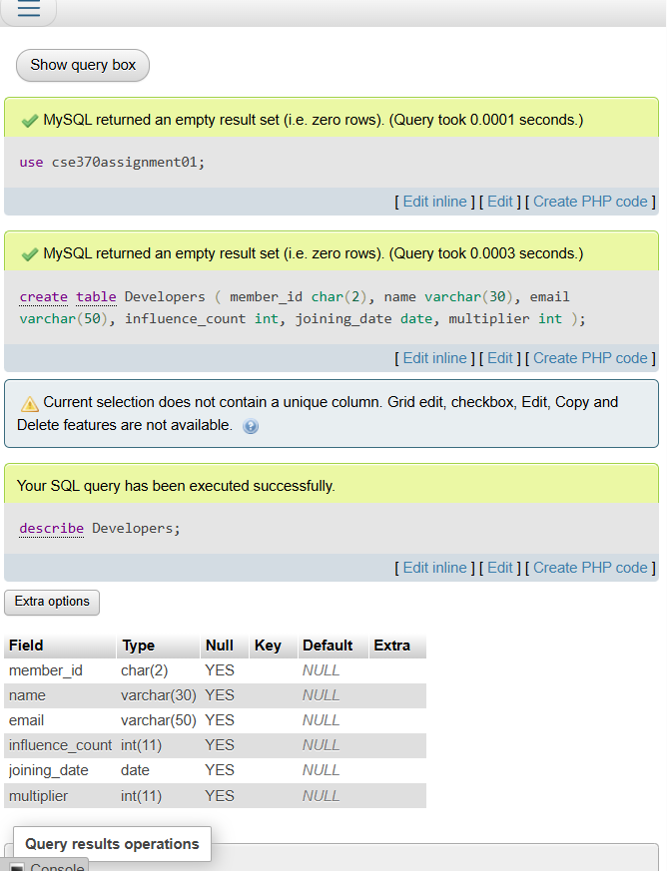

*Step-03:*

insert into Developers (member_id, name, email, influence_count, joining_date, multiplier) values

(1, 'Taylor Otwell', 'otwell@laravel.com', 739360, '2020-6-10', 10),

(2, 'Ryan Dahl', 'ryan@nodejs.org', 633632, '2020-04-22', 10),

(3, 'Brendan Eich', 'eich@javascript.com', 939570, '2020-05-07', 8),

(4, 'Evan You', 'you@vuejs.org', 982630, '2020-06-11', 7),

(5, 'Rasmus Lerdorf', 'lerdorf@php.net', 937927, '2020-06-3', 8),

(6, 'Guido van Rossum', 'guido@python.org', 968827, '2020-07-18', 19),

(7, 'Adrian Holovaty', 'adrian@djangoproject.com', 570724, '2020-05-07', 5),

(8, 'Simon Willison', 'simon@djangoproject.com', 864615, '2020-04-30', 4),

(9, 'James Gosling', 'james@java.com', 719491, '2020-05-18', 5),

(10, 'Rod Johnson', 'rod@spring.io', 601744, '2020-05-18', 7),

(11, 'Satoshi Nakamoto', 'nakamoto@blockchain.com', 630488, '2020-05-10', 10);

select * from Developers;

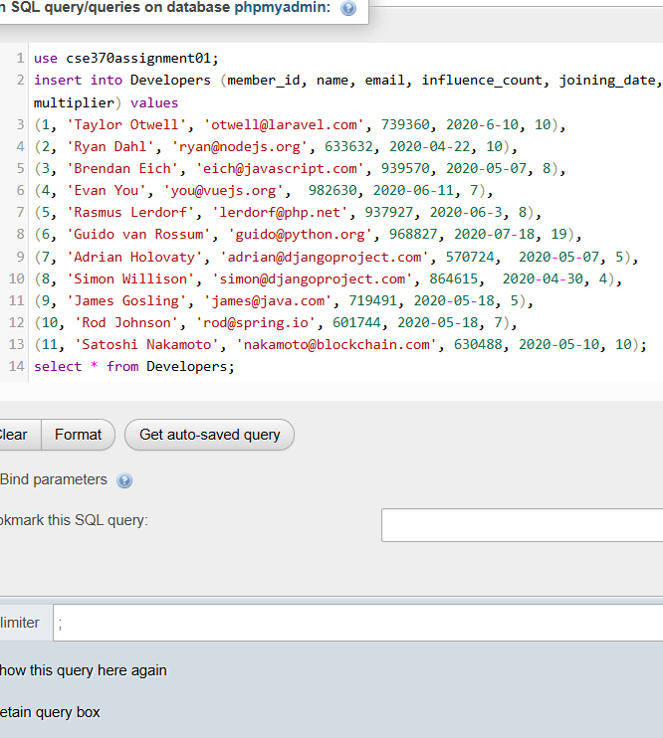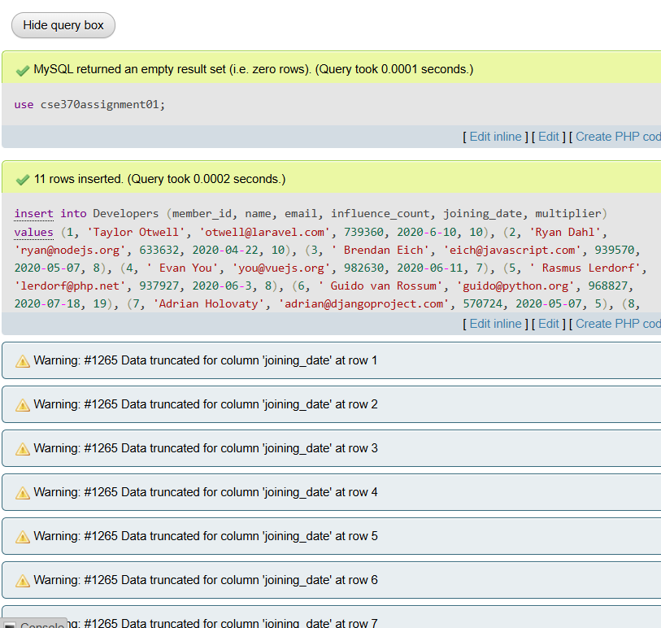

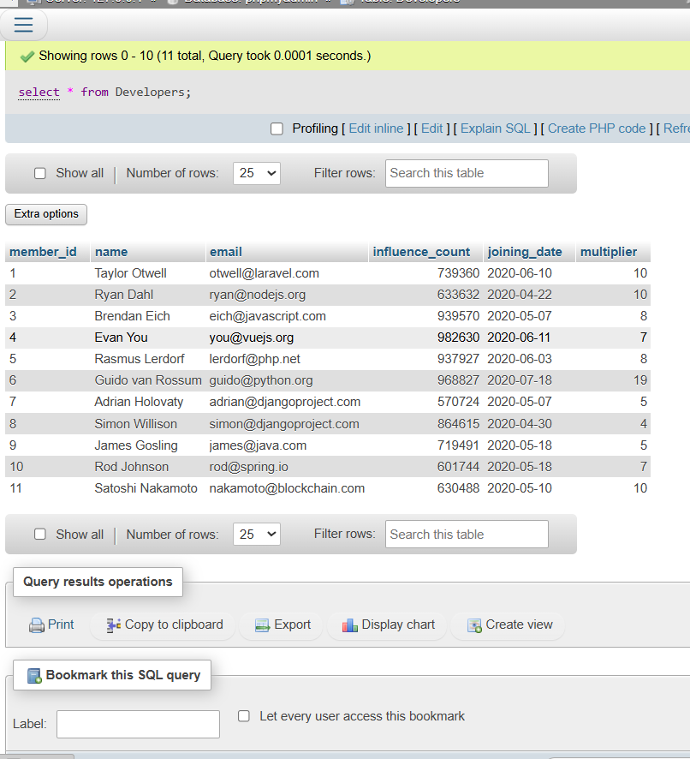

**Answer of Task-02**

use cse370assignment01;

alter table Developers change column influence_count followers int;

describe Developers;

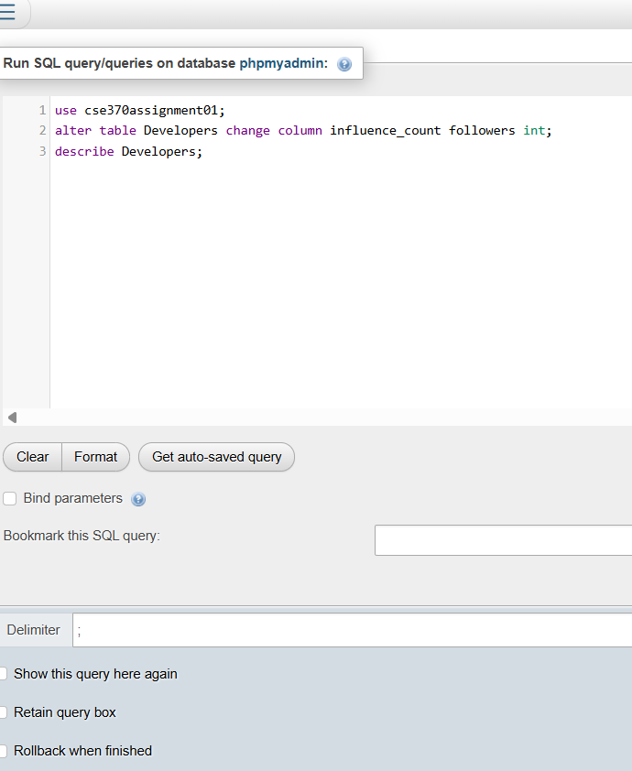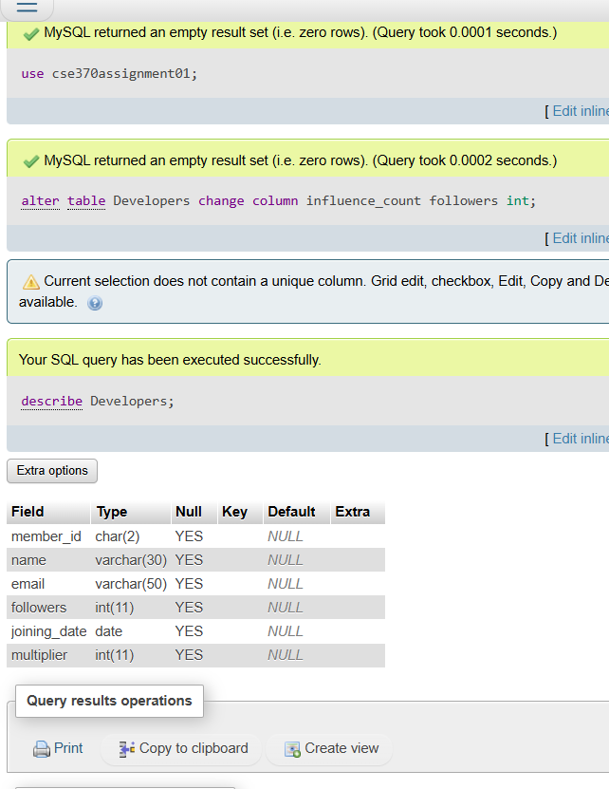

**Answer of Task-03**

use cse370assignment01;

update Developers set followers=followers+10;

select * from Developers;

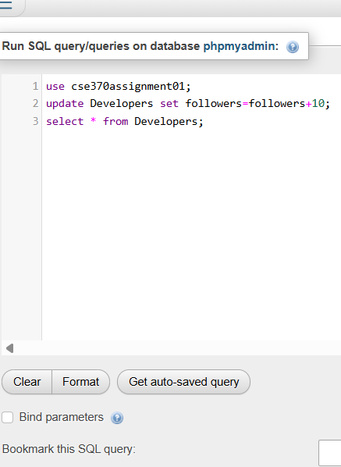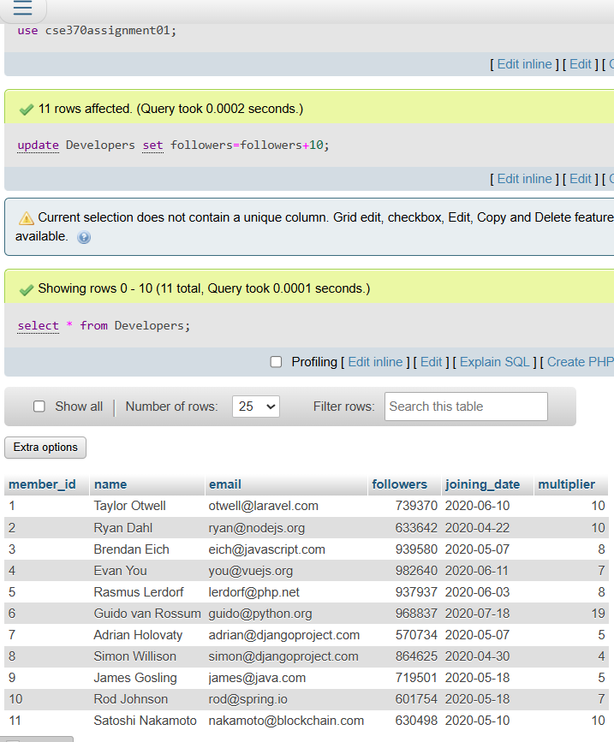

**Answer of Task-04**

use cse370assignment01;

select name, ((followers*100/1000000)*(multiplier*100/20))/100 as Efficiency from Developers;

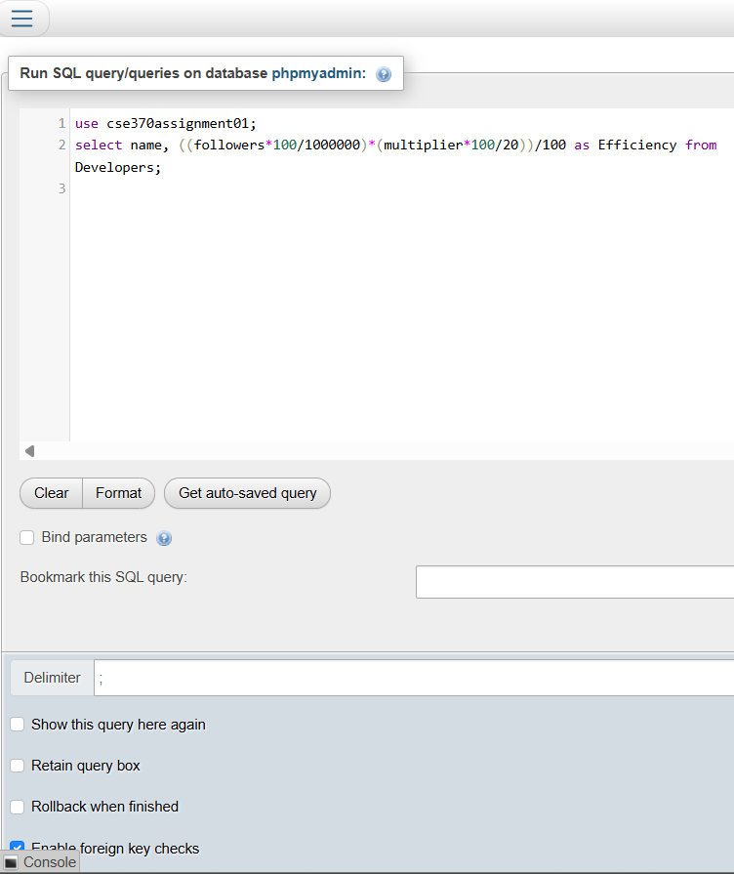

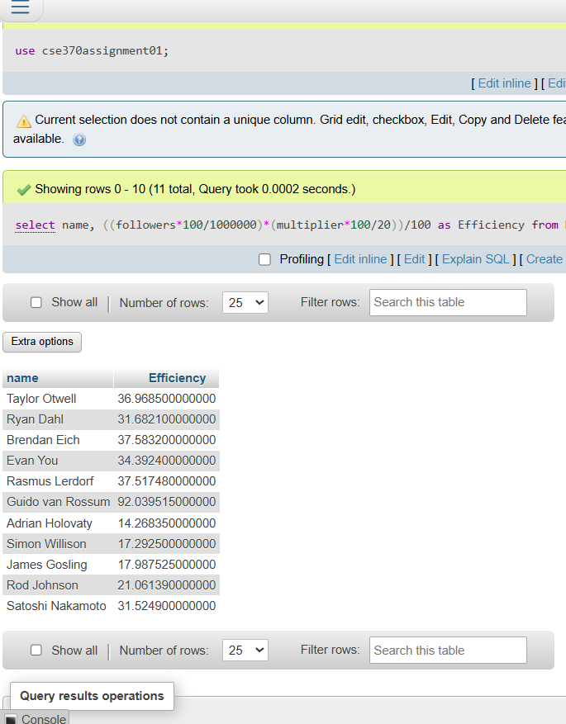

**Answer of Task-05**

use cse370assignment01;

select upper(name), joining_date from Developers order by joining_date desc;

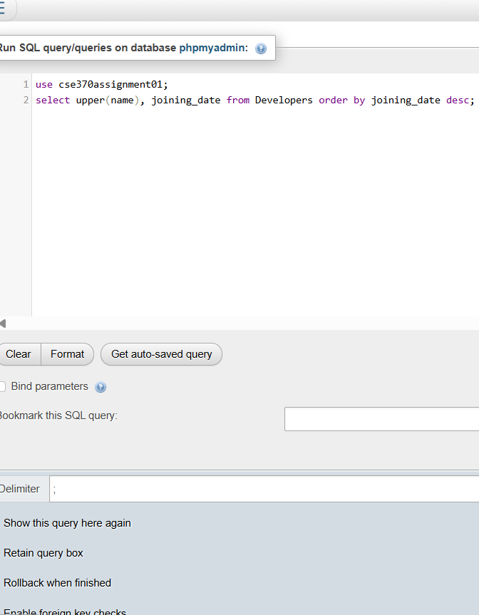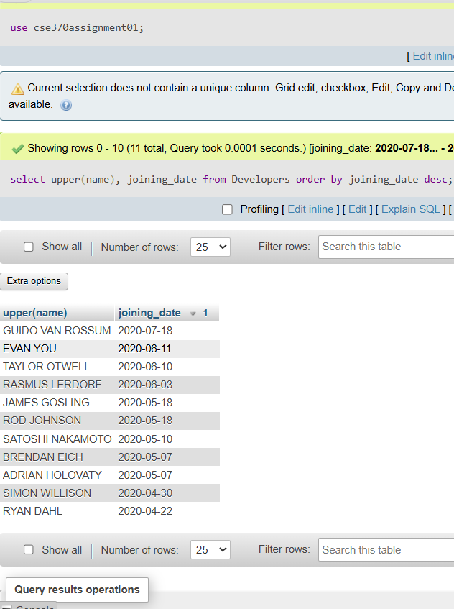

**Answer of Task-06**

use cse370assignment01;

select member_id, name, email, followers from Developers where email like '%.com' or email like '%.net';

